**NAME: B.SAKTHI**

**10/6/24**

Showed the practiced Work

**11/6/24**

Made the below design  
  
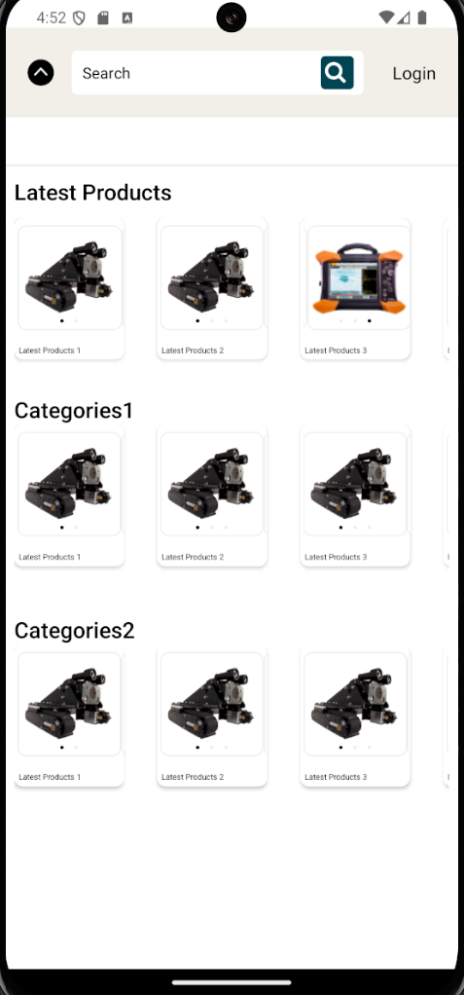  
1)Components used-Header component ,FlatList, ScrollView along with the indicators to show the movement of the pictures within each segment.

2)I maintained the exact styling provided by Santhosh sir.

13/6/23  
did a before-login page similar to Latest products page

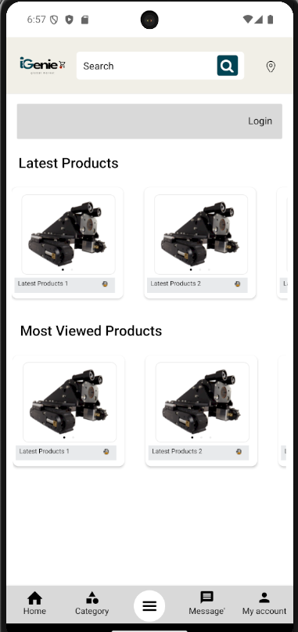

Here i have added Tab bar and used the styling of the previous page for ‘Latest Products’ and ‘Most Viewed Products’.

I imported Tab bar navigation from React Native and modified it according to the required syle.

14/6/24

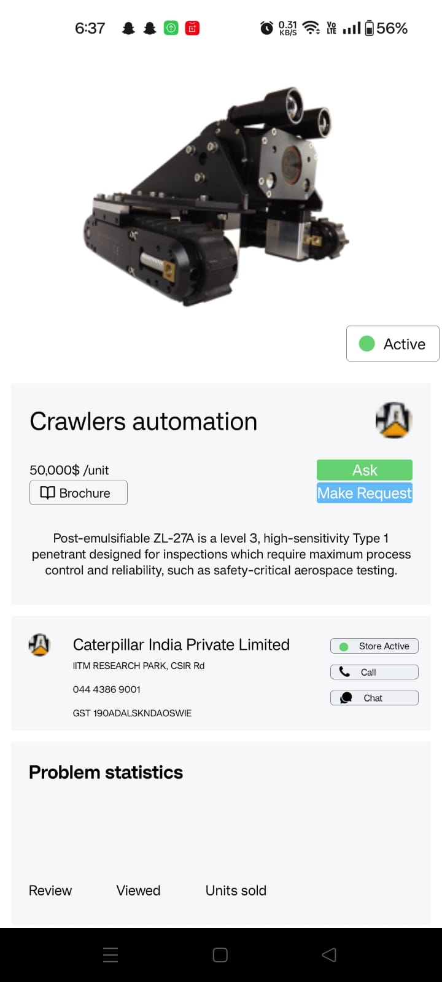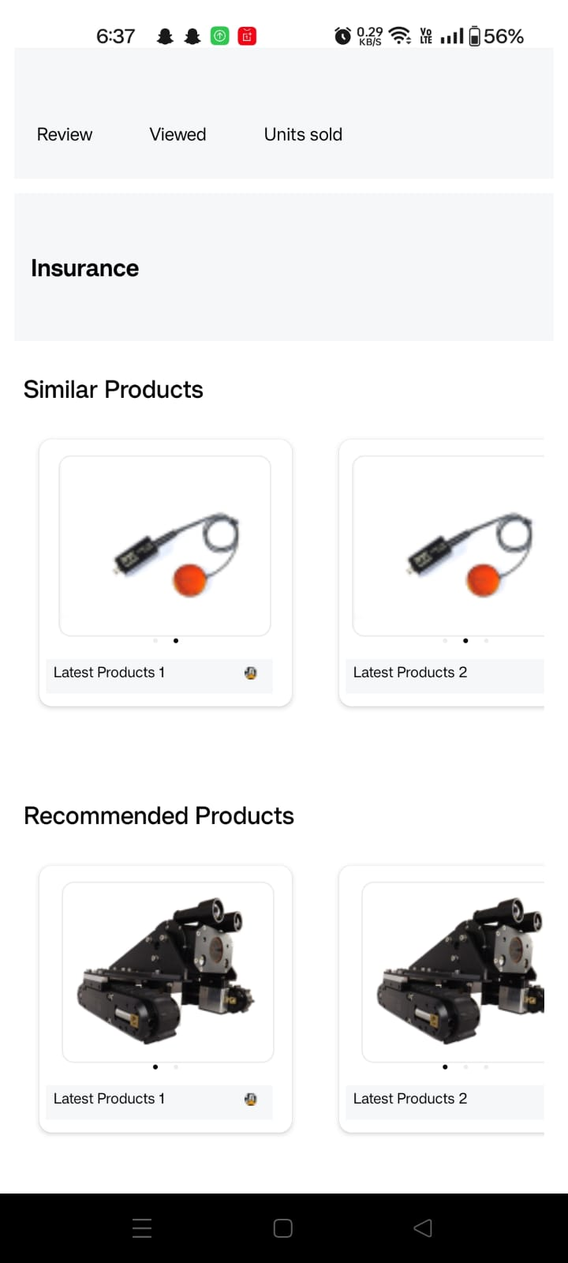

1)I made the above Product details page, where I designed the page such that it is adaptive to all the screens and the alignment remains the same in all the devices.

2)There are 7 seperate view segments in the page and within each segment there are mutiple view segments to make the UI look neater

3)I have confined the number of lines of code to be minimal to increase the readability.

4)I have used ScrollView to scroll the scree and I used the same tag to scroll horizontally to see multiple images in the ‘Similar Products’ and ‘Recommended Products, segment

5)Since the styling of recommended products and Similar products are same, I used a common Jsx and passed the required props to it and displayed the images and description accordingly.

6)I have also added page indicators to indicate which image the useer is seeing.

7)I imported the icon from expo-icon